
SRM Institute of Science and Technology
Mode of Exam
OFFLINE
College of Engineering and Technology
School of Computing
DEPARTMENT OF COMPUTING TECHNOLOGIES
SRM Nagar, Kattankulathur – 603203, Chengalpattu District, Tamilnadu
Academic Year: 2023-2024 (ODD) Batch 1 – SET A
Answer Key
Test: CLAT-1 Date: 9/8/2022 Course Code & Title:18CSE458T/Wireless and Mobile Communication Duration: 50 Mins
Year & Sem: VII Max. Marks: 25

Course Articulation Matrix:
CO/PO | PO1 | PO2 | PO3 | PO4 | PO5 | PO6 | PO7 | PO8 | PO9 | PO10 | PO11 | PO12 | PSO1 | PSO2 | PSO3
CO1 | 3 | 2 | - | - | - | - | - | - | - | - | - | - | - | - | -
CO2 | 2 | - | - | - | - | - | - | - | - | - | - | - | - | - | -
CO3 | 2 | - | - | - | - | - | - | - | - | - | - | - | - | - | 2
CO4 | 3 | - | 1 | - | - | - | - | - | - | - | - | - | - | - | -
CO5 | 3 | 1 | 2 | - | - | - | - | - | - | - | - | - | - | - | -

Part - A
(5 x 1 = 5 Marks)
Instructions: Answer all
Q. No | Question | Marks | BL | CO | PO | PI Code
1 | The relation between bandwidth and audio signal frequency in amplitude modulation is __________.  A. Bandwidth = 3 Frequency  B. Bandwidth = 4 Frequency  C. Bandwidth = 2 Frequency  D. Bandwidth = 6 Frequency  Ans: Bandwidth = 2 Frequency | 1 | 1 | 1 | 1 | 1.6.1
2 | A multiplexer________ several transmission streams while a demultiplexer _______ them  A. combines; separates  B. compress; decompress  C. encrypts; decrypts  D. separates; combines  Ans: combines; separates | 1 | 1 | 1 | 1 | 1.6.1
3 | The period of a signal is usually expressed in _______.  A. Hz  B. volts  C. seconds  D. radians  Ans: seconds | 1 | 1 | 1 | 1 | 1.6.1
4 | Why wireless communication is used?  A. It enables billions of people to connect to the Internet  B. Lowers the cost of network infrastructure  C. Makes services more inexpensive  D. All of the mentioned  Ans: All of the mentioned | 1 | 1 | 1 | 1 | 1.6.1
5 | DSSS system spreads the baseband signal by ________ the baseband pulses with a pseudo noise sequence.  A. Adding  B. Subtracting  C. Multiplying  D. Dividing  Ans: Multiplying | 1 | 1 | 1 | 1 | 1.6.1

Part B
(5 X 2 = 10 Marks)
6 | Mention the elements of wireless transmission.  Ans:  - Sending and Receiving Devices  - Communication Channel  - Connection Devices  - Data Transmission specifications | 2 | 1 | 1 | 1 | 1.6.1
7 | For an amplitude modulated wave, the maximum amplitude is found to be 12V and minimum amplitude is found to be 4V. Find the percentage of modulation index of this wave?  Ans:  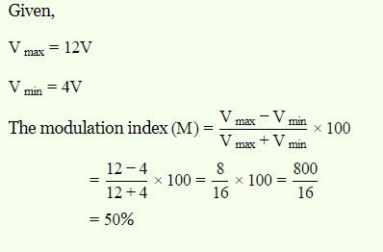 | 2 | 2 | 1 | 1 | 1.6.1
8 | List out the types of Noise.  Ans:  There are several way to classify Noise, but conveniently Noise is classified as  1) External Noise  2) Internal Noise | 2 | 1 | 1 | 1 | 1.6.1
9 | Identify the Characteristics features of the Spread Spectrum.  Ans:  - Higher channel capacity.  - Ability to resist multipath propagation.  - They cannot easily intercept any unauthorized person.  - They are resistant to jamming.  - The spread spectrum provides immunity to distortion due to multipath propagation.  - The spread spectrum offers multiple access capabilities | 2 | 1 | 1 | 1 | 1.6.1
10 | Differentiate between narrow band and wide band signal?  Ans:  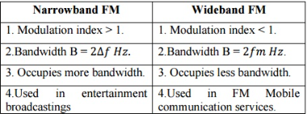 | 2 | 2 | 1 | 1 | 1.6.1

Part – C
( 1 x 10 =10 Marks)
Instructions: Answer any one
11 a.  b. | Define the term Multiplexing. Explain the FDM and TDM with one example each.  Ans:  Multiplexing  – FDM  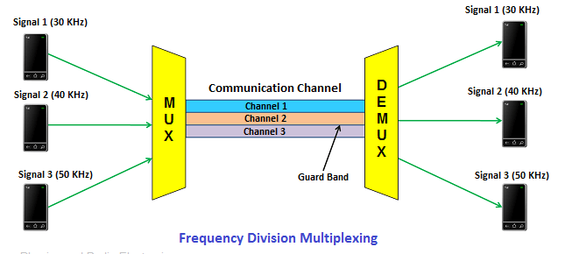  – TDM  - Synchronous TDM  - Asynchronous TDM  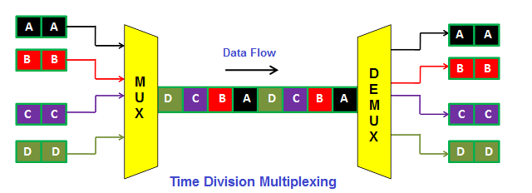  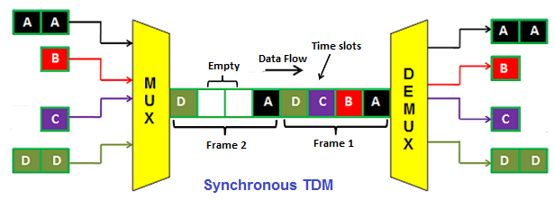  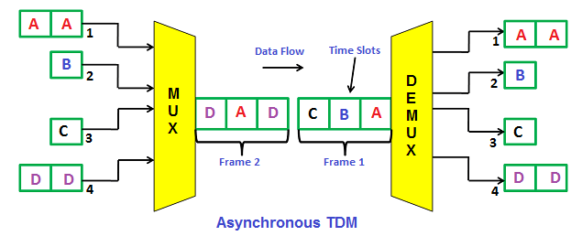  (or)  Explain the working principle of Frequency Hopping Spread Spectrum (FHSS) and its significance in wireless communication. Provide a diagram to illustrate the concept.  Ans:  Frequency-hopping spread spectrum (FHSS) transmission is the repeated switching of the carrier frequency during radio transmission to reduce interference and avoid interception.  There are some of the advantages of frequency hopping spread spectrum (FH-SS) given below : It has less distance effect. Provide the greatest amount of spreading. The bandwidth of these systems is large.  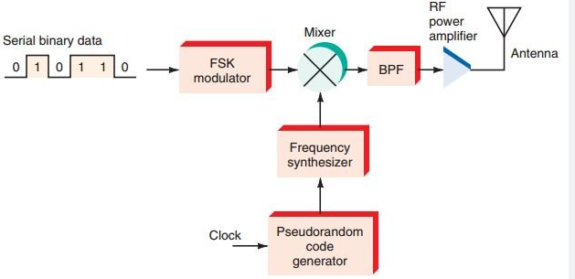 | 10 | 2 | 1 | 1 | 1.6.1

Course Outcome (CO) and Bloom’s level (BL) Coverage in Questions
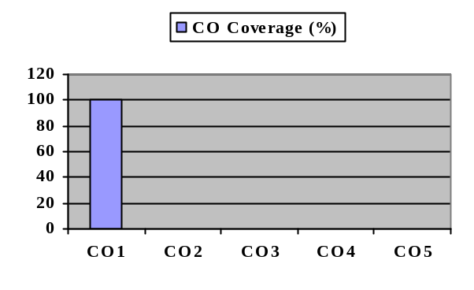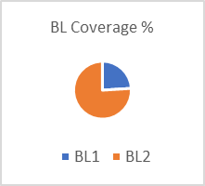

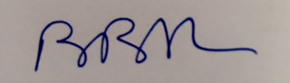

Approved by the Audit Professor/Course Coordinator

